P5 Assignment - Team Points

Create a P5.js program called ***Assign3_Points*** to keep track of points in a competition such as a Music Competition or a Sports League.

* In sports, the general rule is that a win is worth 2 points. (We will assume there are no ties, no overtime, etc.).
* For other types of competition, you will need to come up with another sort of calculation (perhaps an average score of several judges)

Step 1 - Set Up

Set up your canvas to be 800,600 to start. Give yourself a light colored background.

Step 2 - Set up Team Names

a) Create a variable called team1name.

b) Put the name of a team into the variable

c) Repeat the above for 2 more teams. Use team2name and team3name.

Step 3 - Set Up Wins and Losses (or Judges Scores, or ???)

Create variables for the wins and losses of **3 teams** and decide how many wins and losses each should have. For example:

*team1Wins = 9;*

*team1Losses= 7; (do this for all 3 teams)*

Step 4 - Calculate Points

Create 3 more variables that store the total points for each team (such as team1Points). The points must be calculated using a formula.

* One formula for calculating total points is wins * 2. Make sure you use the team?wins variable.

Step 5 - Print Titles

Note, you may want to read and complete the ‘Final 10%’ section before beginning this step.

a) Adding a font is optional. Make your font color is dark.

b) Using text(), headings row for a table that you will fill with stats: For a sports league, it might look like:

*Team Wins Losses Points*

For a music competition, it might look like:

*Team Judge 1 Judge 2 Average*

Step 6 - Print all statistics

Underline the headings row using a simple line().

Using the variables, print out the statistics table.

Overall, your table should look similar to the following:

*Team Wins Losses Points*

*____________________________________________*

*Eskimos 9 7 18*

*Argos 6 10 12*

*Stampeders 2 14 4*

or

*Competitor Judge 1 Judge 2 Total*

*__________________________________________*

*KPop Kids 45 37 82*

*Poppin’ Bob 39 65 104*

*Coups Troop 80 78 158*

Stop here for 80%

Next 10% - Step 7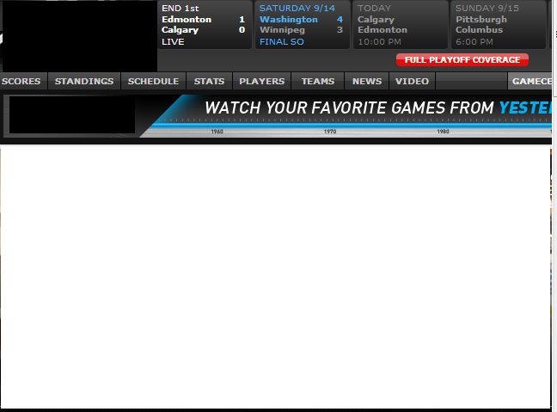

Add a keyPressed and mousePressed function to your program so that:

* Note: updated to make it easier to understand
* Every time you click a mouse, the first team wins an additional game
* Every time you press a key, your second team wins.

Be sure to recalculate your teamPoints variables if they do not already update.

Final 10% - Step 8 - Background Picture

1. Add a background image such as the following taken from TSN. You can find a few similar ones on our network here: T:\Computer Science\Images and Sounds\Miscellaneous
2. Adjust the location of your text to look good with the picture.

Evaluation

I will be checking out the following:

* does the program work
* proper set up and use of variables
* good use of text statements (does the stats table look like a table, etc.)

Setting up variables - 50%

Printing Table - 30%

KeyPressed & MousePressed Functions - 10%

Background Picture 10%